- The four greatest masters of Colombian piano on a single stage.
- Teresita Gómez, Blanca Uribe, Helvia Mendoza y Ruth Marulanda.
- May 23, 8:00 p.m.
- Cafam Theater

On Thursday, May 23, 2024, at 8:00 p.m., the Cafam Theater will feature a historic concert in which Colombian music will have the prominence, talent, and flavor of bambucos, pasillos, guabinas, dances, cumbias, and all the splendor of our rhythms and traditions. For the first time, the four preeminent pianists of our country will meet to pay tribute to our homeland, our history, and our culture.
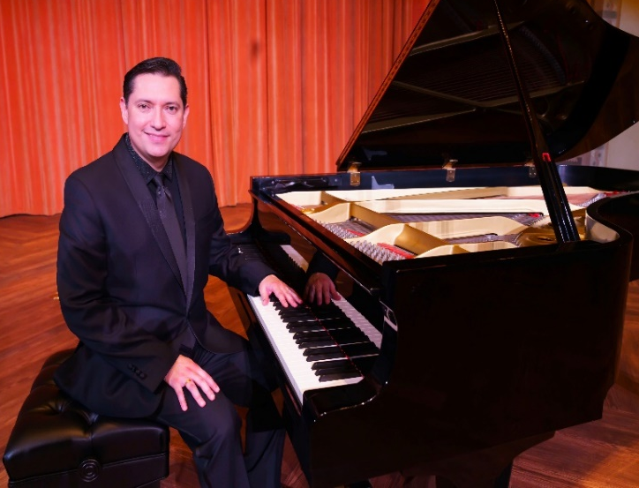
This unforgettable concert will come to fruition thanks to the hard work of the ColomPiano Corporation in co-production with the Cafam Theater, which enhances the promotion of Colombian music for piano at various levels, including the rescue and dissemination of this musical genre. ColomPiano was founded and is currently managed by a combined scientist and pianist and an artist of musical cradle, Dr. Alvaro Puig Rodríguez. Dr. Puig Rodriguez is a Colombian physician with postgraduate studies in internal medicine, hospital medicine, and endocrinology. He is the current president of the Medical Society of Northern Virginia. Dr. Puig Rodriguez is a consummate artist with a great affinity for classical and traditional music. As a child, he began his professional piano studies with pianist Ruth Marulanda and has actively participated in numerous festivals and musical gatherings in various regions of Colombia and the United States, where he always includes works by Colombian composers in his recitals. Today, he is the manager and director of this memorable and emblematic concert that pays tribute to the piano and Colombian music. You can view information pertaining to ColomPiano at website https://colompiano.com/

On this occasion, Teresita Gómez, Blanca Uribe, Helvia Mendoza, and Ruth Marulanda will present a concert of flavors, feelings, stories, and Colombian music in a tribute to the talent of those who have dedicated their lives to the piano as an instrument and to music as a lifestyle.

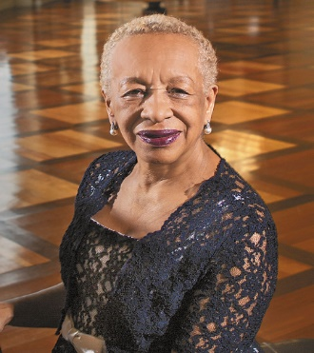
Teresita Gómez, is a teacher and an Antioquian pianist of classical music. She has received recognition from both inside and outside of the Colombian borders. Among her credits is the Cross of the Order of Boyacá in the rank of Commander for her artistic trajectory, contribution to the musical culture, and honorable representation of Colombia abroad.

In 2017, in honor of her sixty-year artistic career, she received two awards: one from the University of Antioquia for lifetime achievement and the second, the Juan del Corral Gold category recognition, from the Government of Antioquia for her musical contribution and artistic life.

Blanca Uribe, is a Steinway artist who has established herself as one of the most important pianists in the country. She is a teacher and a connoisseur of classical and Colombian music. She is also known for her interpretations of Ludwig van Beethoven's Sonatas, Isaac Albéniz's The Iberia Suite, and other important, colossal works of the classical pianistic repertoire. Ms. Uribe’s career began at the age of eleven when she debuted with the Colombian Symphony Orchestra. She has performed on the main stages of the United States, Latin America, and Europe in recitals with major orchestras.

Helvia Mendoza, a Colombian pianist, began her brilliant career and training process in Cartagena with Josefina De Sanctis and later in Bogotá with Lucía Pérez until obtaining the degree of pianist at the Conservatory of the National University. Subsequently, she has toured prestigious national and international stages, at which she has printed her seal of quality and musical recognition. Critics have given glowing reviews of her recordings featuring the works for piano of several Colombian composers.

Ruth Marulanda, "the Colombian pianist who learned to play with one hand," noted in a press release that she preferred to play Colombian music and not classical music at the Vienna Conservatory. Ruth Marulanda is an institution and a legacy for the country's peasant and traditional music. Occasionally, she has been nicknamed “the mother of Colombian music.” This preeminent artist grew up among currulaos, pasillos, and bambucos in gatherings led by her father and siblings. This stimulated her desire to pursue piano with well-known piano teachers, such as Carmen Vicaría de Escobar in her hometown of Buga, Valle del Cauca.

At this special event, we will have four celebrated pianists of Colombian music who will come together to delight lovers of our rhythms, to enjoy the masterful interpretation of the piano, and to feel with passion our land and its idiosyncrasies.
Save the date for Thursday, May 23, 2024, at 8:00 p.m., at the Cafam Theater, located at Avenida Carrera 68 # 90 - 88, Bogotá - Colombia.
Enter the QR code below or visit the link below: https://www.tuboleta.com/eventos/detalle/maestras-del-piano-colombiano/412973439656 and buy your tickets.

We look forward to seeing you!

Information and press:
Nidia Yaneth Martínez
Cel. (571) 3212340400
Design and digital marketing:
Manuel Eduardo Martín

